HOMEWORK3

rahaf alomar - 435201926

# Problem1:

## 1.1:

**Postfix notation:** **A B C * D / E F ^ * ‎–‎ G +**

## 1.2:

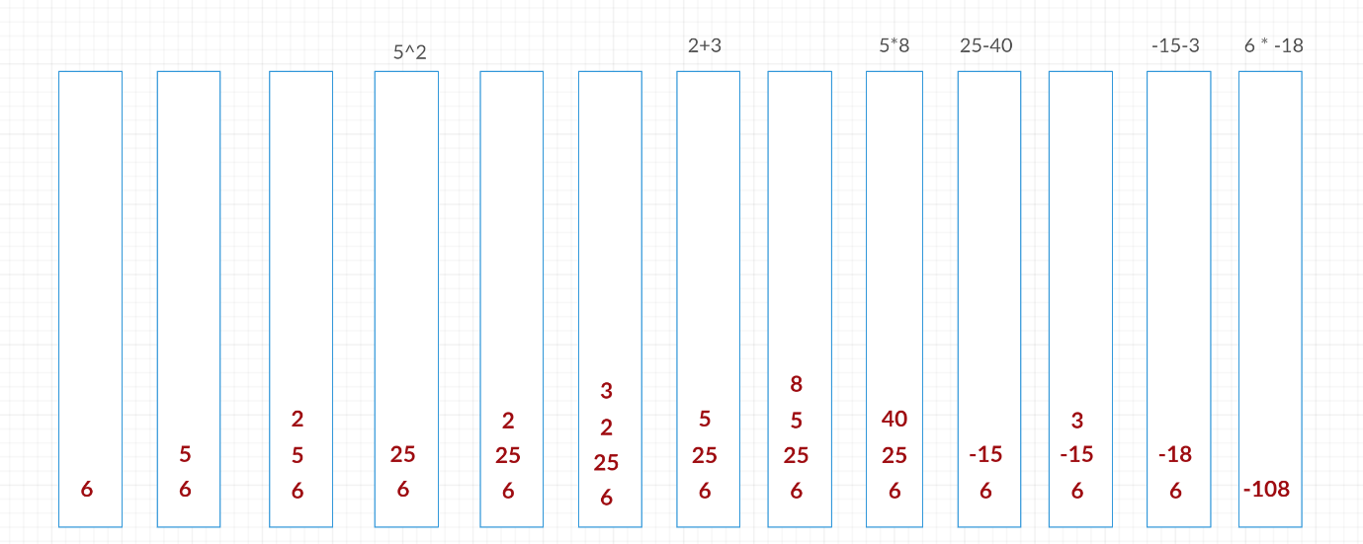

**6 5 2 ^ 2 3 + 8 * ‎–‎ 3 ‎–‎ * = ‎–‎ 108**

## **1.3:**

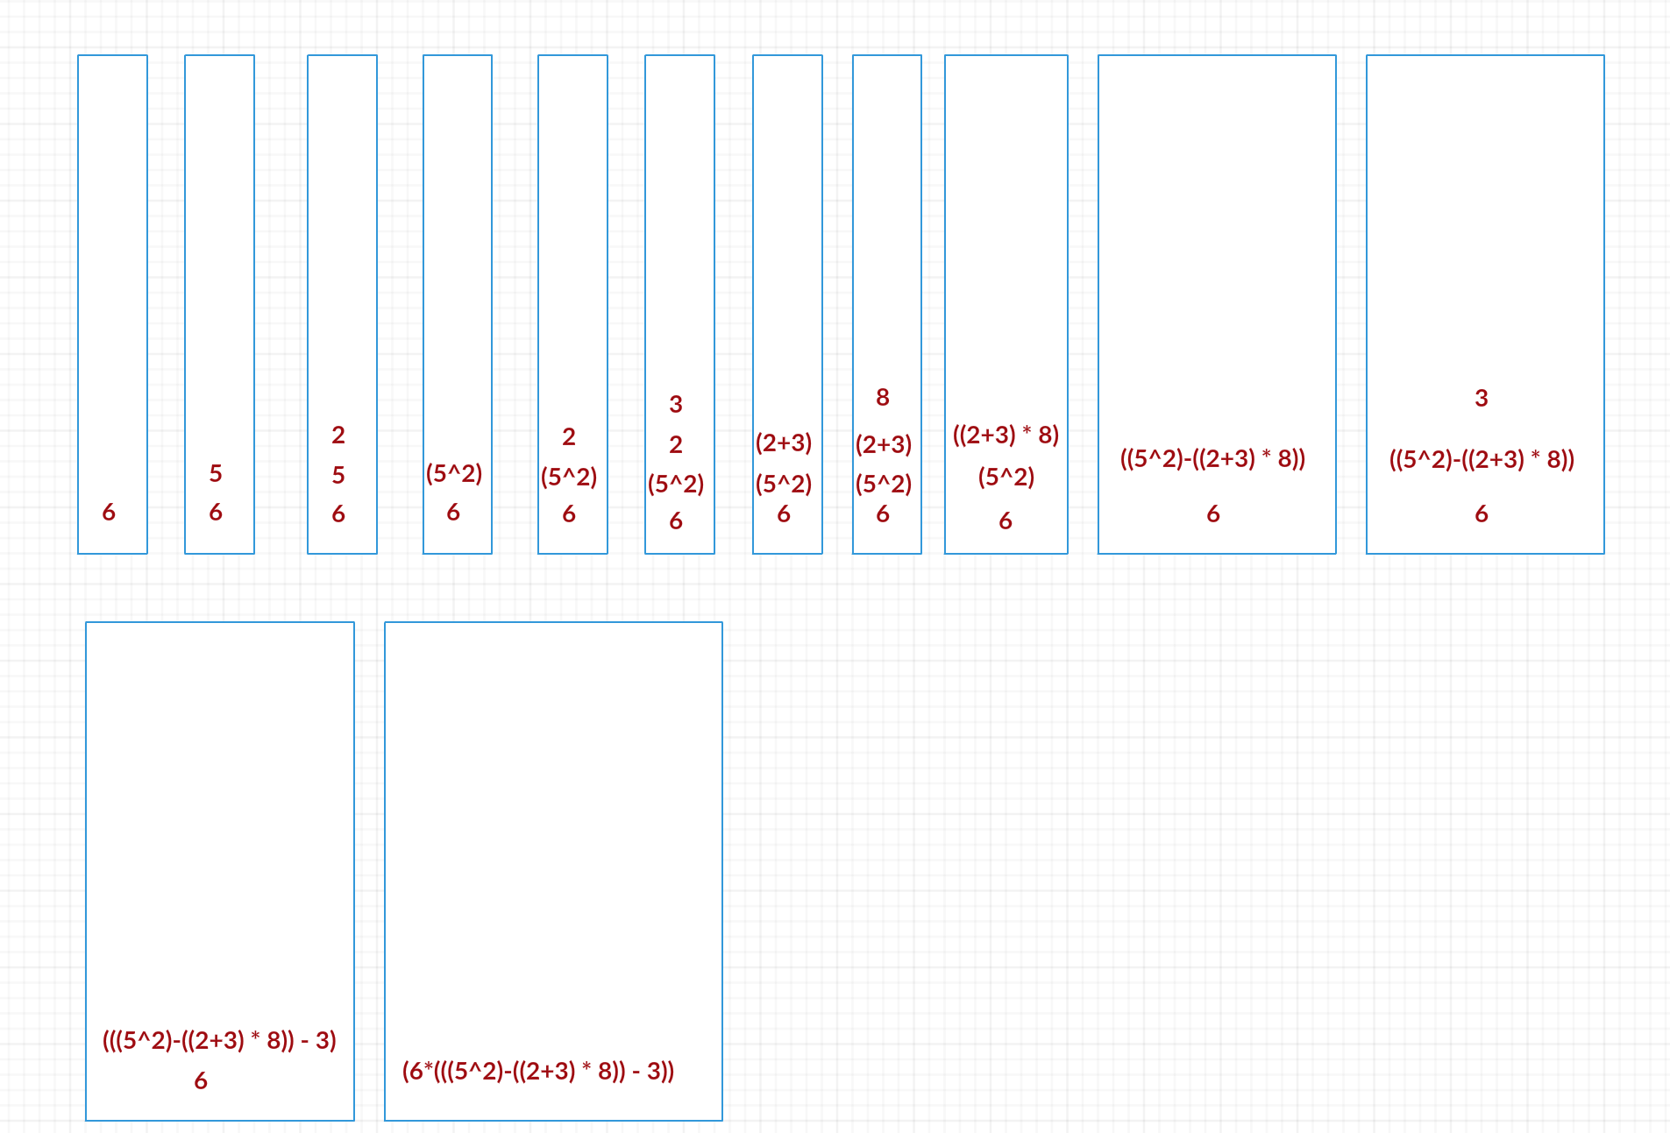

**infix notation: ( 6 * ( ( ( 5 ^ 2 ) ‎–‎ ((2+3) *8 )) – 3 ))**

## **1.4:**

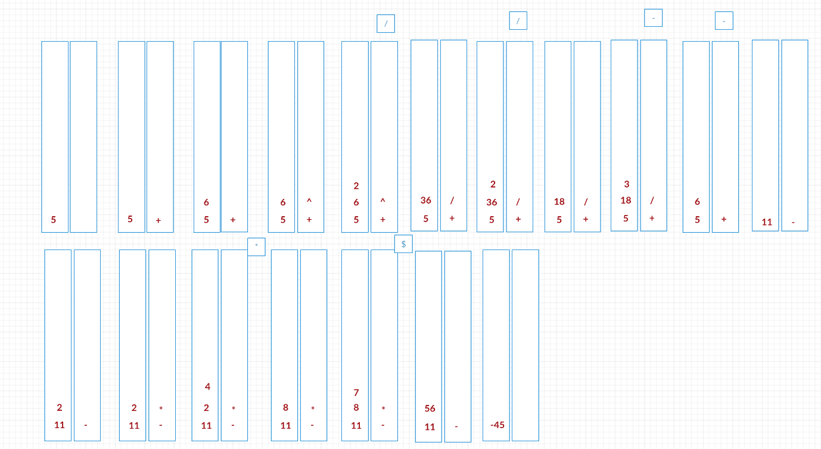

**5 + 6 ^ 2 / 2 / 3 - 2 * 4 * 7 = - 45**

# Problem2:

## 2.1:

**public** **static** <T> **void** removeLast(Stack<T> st) {

Stack‎<T> tmp = **new** Stack‎<T>();

**while** (!st.empty()) {

tmp.push(st.pop());

}

**if** (!tmp.empty())

tmp.pop();

**while** (!tmp.empty())

st.push(tmp.pop());

}

## 2.2:

**public** **static** <T> **boolean** topEqualsBottom(Stack<T> st) {

**if** (st.empty())

**return** **true**;

Stack<T> tmp = **new** Stack<T>();

T top = st.pop();

tmp.push(top);

T bottom = **null**;

**while** (!st.empty()) {

bottom = st.pop();

tmp.push(bottom);

}

**while** (!tmp.empty())

st.push(tmp.pop());

**return** top.equals(bottom);

}

# pronlem3:

## 3.1:

**public** **static** **boolean** containsMult3(**int**[] list, **int** index) {

**if** (index + 1 == list.length)

**return** (list[index] % 3 == 0);

**if** (list[index] % 3 == 0)

**return** **true**;

**return** *containsMult3*(list, index + 1);

}

## 3.2:

**public** **static** **boolean** sameSign(**int**[] list, **int** index) {

**if** (index + 1 == list.length)

**return** list[index] != 0;

**if** ((list[index] > 0 && list[index + 1] < 0) || (list[index] < 0 && list[index + 1] > 0) || list[index] == 0)

**return** **false**;

**return** *sameSign*(list, index + 1);

}

# problem4:

## 4.1:

**public** **boolean** recSearch(T k) {

**return** recSearch(k, head);

}

**private** **boolean** recSearch(T k, Node<T> tmp) {

**if** (tmp == **null**)

**return** **false**;

**if** (tmp.data.equals(k))

**return** **true**;

**return** recSearch(k, tmp.next);

}

## 4.2:

**public** **void** reverse(){

reverse(0);

}

**private** **void** reverse ( **int** index){

**if** (index == top/2)

**return**;

T tmp = nodes[index];

nodes[index] = nodes[top-index];

nodes[top-index]= tmp;

reverse(index+1);

}

# problem5:

## 5.1:

**public** <T> **void** InsertAtBottom(Stack<T> st, T e) {

**if** (st.empty()) {

st.push(e);

**return**;

}

T tmp = st.pop();

*InsertAtBottom*(st, e);

st.push(tmp);

}

## 5.2:

**public** <T> **void** reverse(Queue<T> q) {

**if** (q.length() == 0)

**return**;

T tmp = q.serve();

*reverse*(q);

q.enqueue(tmp);

}

## 5.3:

**public** <T> Queue<T> merge(Queue<T> q1, Queue<T> q2) {

**return** *recMerge*(q1, q2, **new** Queue<T>());

}

**public** <T> Queue<T> recMerge(Queue<T> q1, Queue<T> q2,Queue<T> q) {

**if** (q1.length() == 0 && q2.length() == 0)

**return** q;

**if** (q1.length() != 0)

q.enqueue(q1.serve());

**if** (q2.length() != 0)

q.enqueue(q2.serve());

**return** *recMerge*(q1, q2, q);

}

## 5.4:

**public** <T> Queue<T> merge2(Queue<T> q1, Queue<T> q2) {

**return** *recMerge2*(q1, q2, **new** Queue<T>(), 0, 0);

}

**public** <T> Queue<T> recMerge2(Queue<T> q1, Queue<T> q2,Queue<T> q, **int** i, **int** j) {

**if** (q1.length() == i && q2.length() == j)

**return** q;

T tmp1 = **null**, tmp2 = **null**;

**if** (q1.length() != i) {

tmp1 = q1.serve();

q.enqueue(tmp1);

q1.enqueue(tmp1);

i++;

}

**if** (q2.length() != j) {

tmp2 = q2.serve();

q.enqueue(tmp2);

q2.enqueue(tmp2);

j++;

}

**return** *recMerge2*(q1, q2, q, i, j);

}